1. Modified class diagram with command pattern

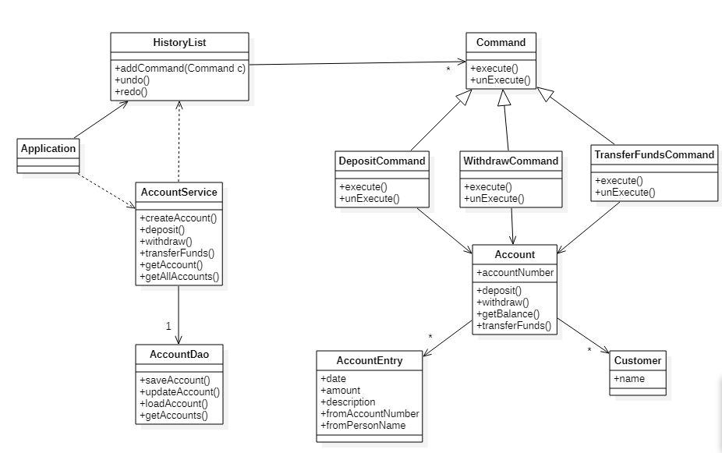

1. Sequence diagram for deposit, withdraw and redo.

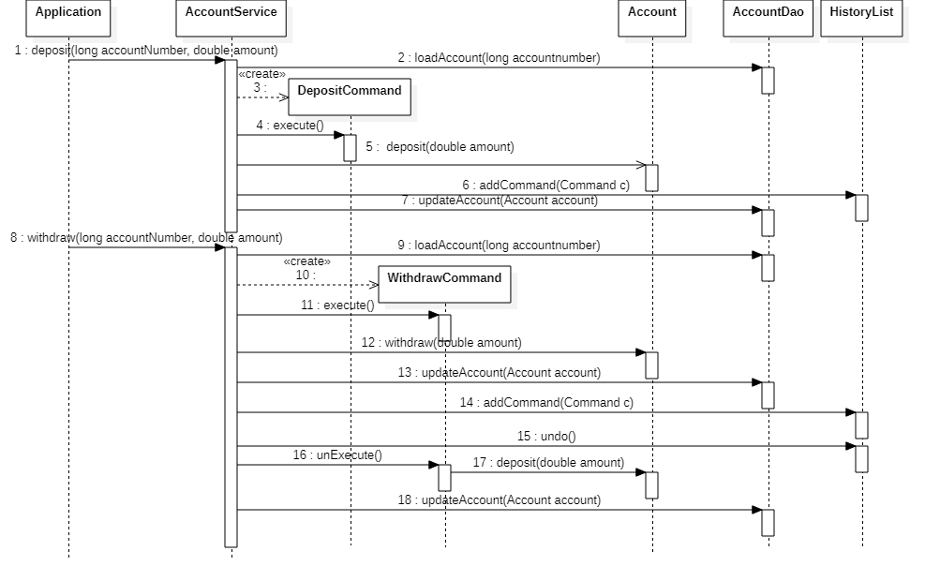

1. Modified Code attached.
2. Modified class diagram.

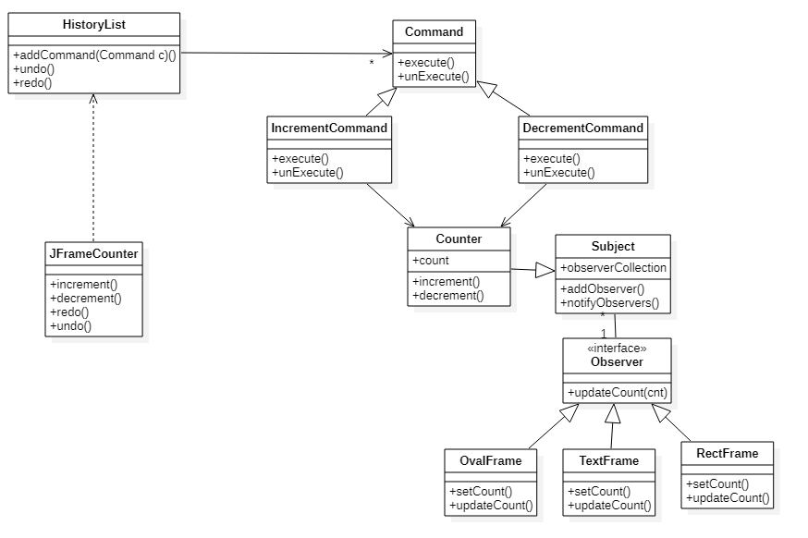

1. Sequence diagram with an undo.

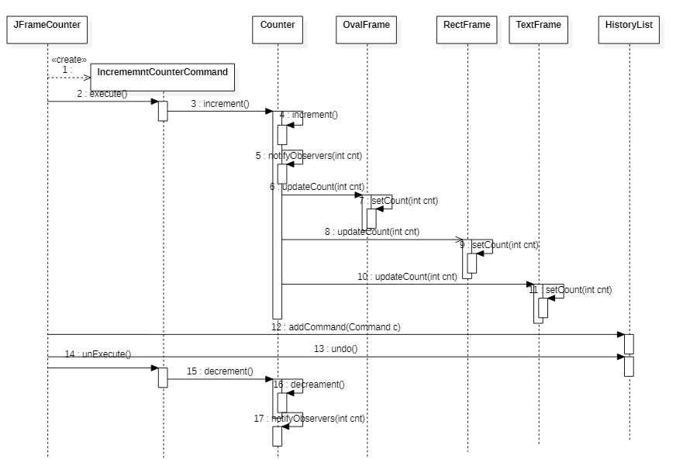

1. Modified code attached